Chemistry of nano-materials 20-03-2020

Syllabus:
- Introduction to nanomaterials
- Synthesis methods (Top-down and bottom-up approaches)
- Hydrothermal method
- Solution combustion
- Characterization techniques
- Applications of nanomaterials in various fields

Introduction:
Nanomaterials are corner stones of nanoscience and nanotechnology. Nanostructure science and technology is a broad and interdisciplinary area of research and development activity that has been growing explosively worldwide in the past few years. It has the potential for revolutionizing the ways in which materials and products are created and the range and nature of functionalities that can be accessed. It is already having a significant commercial impact, which will assuredly increase in the future.
Nanoscience: The study of phenomena and materials at the atomic, molecular and macromolecular scales, where properties differ significantly from those at the larger scale
Nanotechnology: Design, characterization, production and application of structures, devices and systems by controlling morphology (size, shape and distribution) at the nano-scale.
Q What are nanomaterials?
Nanoscale materials are defined as a set of substances where at least one dimension is less than approximately 100 nanometers. A nanometer is one millionth of a millimeter - approximately 100,000 times smaller than the diameter of a human hair. Nanomaterials are of interest because at this scale unique optical, magnetic, electrical, and other properties emerge. These emergent properties have the potential for great impacts in electronics, medicine, and other fields.
Q How nanomaterials are synthesized?
Nanomaterials are made by two generalized processes
- Top down: Start with the big chunk and cut away material to make what you want. It begins with bulk materials that are subsequently reduced into nanomaterials.
Ex: Inert gas condensation, Ion beam technique, Laser ablation, etc



Bottom -up Top down
- Bottom -up: Building what you want by assembling it from small prefabricated units molecules react under chemical or physical circumstances to form nanomaterials. such as atoms and molecules. It begins with atoms and molecules/. These atoms or
Ex: Hydrothermal, Sol-gel method, Co-precipitation and Combustion synthesis

Q. Explain synthesis of nano particles using hydrothermal method
It is a solution based method to prepare wide range of nanomaterials having diverse shapes and size. It is a method to produce different chemical compounds and materials using closed-system in aqueous solutions at temperatures above 100°C and pressures above 1 atm.
Principle: It is based on the principal of dissolution and recrystallizing substances from high temperature aqueous solutions at high vapour pressure. The crystal growth is performed in an apparatus consisting of a steel pressure vessel called autoclave, in which a nutrient (precursors) is supplied along with water. A gradient of temperature is maintained at the opposite ends of the growth chamber so that the hotter end dissolves the nutrient and the cooler end causes end causes seeds to take additional growth.
Procedure: In typical hydrothermal synthesis, stoichiometric amount of precursors and ~20-25 ml of double distilled water are taken in a Teflon liner. In few cases to maintain the basic pH alkali like NaOH or KOH are also added. Then the mixture are stirred well using magnetic stirrer to ensure complete homogenous mixing, until all the contents are evenly distributed. Later, the Teflon liner is kept inside the autoclave and sealed firmly. The complete autoclave assembly is then kept in a Hot air oven at a desired temperature (generally < 150 ^{O}C) and reaction is carried for desired time (Depending on material time varies between 2 and 24 h). Then, after the reaction, the product is washed with water and ethanol to remove impurities and the products are dried at 60 ^{O}C for 3 h in a dust proof hot air oven to get nanocrystalline materials.
For example: Preparation of BiFeO₄ by hydrothermal - Equimolar mixtures of bismuth nitrate (Bi(NO₃)₃.5H₂O) and iron nitrate (Fe(NO₃)₃.9H₂O) are dissolved in distilled water. Add 8 M sodium hydroxide (NaOH) and stir for 30 min and poured into an autoclave. The hydrothermal treatment is conducted at 180 ºC for 12 h. The produced powder is collected at the bottom of the autoclave after cooling to room temperature. The product is washed several times by repeated cycles of centrifugation in distilled water and ethanol. The obtained powder is heated at 80 ºC for 1 hr.

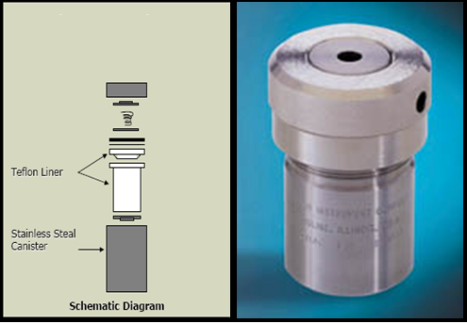

Q What are the advantages and disadvantages of hydrothermal method?
Advantages:
- High efficient and low-cost production of advanced materials
- Crystalline, single and multi-component oxide materials
- Environmentally safe and simple process, since water is used
- It involves H₂O both as a catalyst and component of solid phases at elevated temperature (> 150 °C) and pressure (> a few atmosphere).
- It is the suitable method for the growth of large good-quality crystals while maintaining good control over their composition.
- Inorganic nanomaterials that cannot be prepared by other wet chemical methods can be prepared by hydrothermal methods. Eg: Zns , Y₂O₂S, YF₃ etc.
- A good control over the morphology and size of the nanomaterials can be achieved by hydrothermal method.
Disadvantages:
- Large quantity of product can’t be obtained i.e the yield is less.
- High reaction time.
- Un safety method – working with high pressure autoclaves

Q. What is solution combustion synthesis? Mention the advantages of this method. Explain synthesis of nano ZnO particles using solution combustion method.

Solution combustion process is a self-propagating high temperature synthesis in which exothermic reaction takes place accompanied by the evolution of gases

Oxidizer (O) metal nitrate
Distilled water
O/F=1
Combustion
(Flame-temperature 900-1200 °C)
Nanocrystalline powder of metal oxide
Aqueous redox mixture in preheated muffle furnace (~400 °C)
Fuel (F)
Dehydration

Flow – Chart for synthesis of nano particles by solution combustion method

.
It is another wet-chemical method like sol-gel and hydrothermal, which has been proved to be an excellent technique for preparing several grams micro/nanocrystalline materials due to its short processing time, low processing temperature. This technique is based on exothermic redox reactions that undergo self-sustaining combustion. Mixtures of oxidizer (usually metal nitrates) and a fuel (organic compound containing carbon and hydrogen; e.g. urea, citric acid or glycine as fuel) undergo spontaneous combustion under heating and the chemical energy from the exothermic reaction heats the precursor mixture to high temperatures. Such a high temperature leads to formation and crystallization of nano materials.).
Advantages of solution combustion method:
Among wet chemical routes, the low temperature solution combustion process is an attractive one and finds several advantages like-
- The synthesis temperature (300 ^{O}C) employed is lower than those currently used in conventional route.
- Simple and energetically attractive process.
- Ability to dope desired amounts of impurity ions with better homogeneity.
- The powders are voluminous, foamy, sinteractive and in nanoscale having large surface area.
- Short reaction time (few seconds to 5 minutes)
- Chemical homogeneity

Example: Synthesis of ZnO nano particles by solution combustion method: Refer lab manual

Q - Mention the various techniques used in characterization of nano powder sample
The various characterization techniques used are – (i) Powder X-ray diffraction (ii) Scanning electron microscopy (SEM) (iii) Transmission electron microscopy (TEM)
Detail of the above characterisation is need not study
(i) Powder X-ray diffraction: X-rays are passed through a crystalline material and the pattern produced and gives information on phase purity and crystallite size of the product.. X-ray beam diffracted from a lattice plane can be detected when the X-ray source, the sample and the detector are correctly oriented to give Bragg diffraction. If X-ray beams strikes nano powder sample, they will pass directly through the sample and diffracted beams are collected by a detector and X-ray diffraction pattern is obtained.
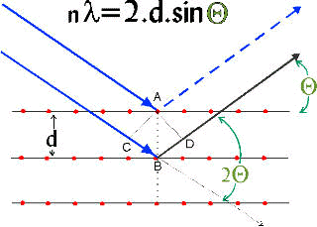
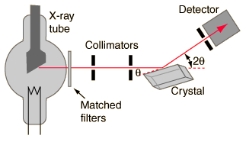
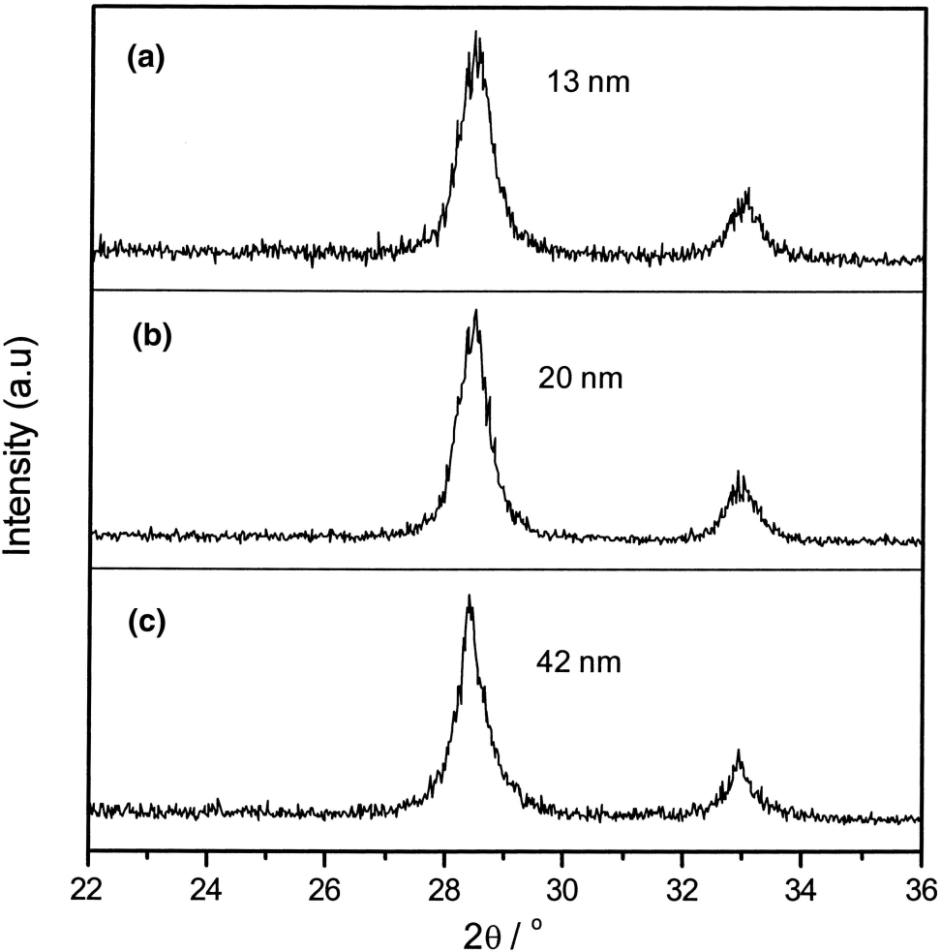
Fig: The crystallite sizes of nano powders determined by Scherrer’s formula
The average crystallite size (D) of nano materials can be estimated from the line broadening in X-ray powder ie., the full width at half-maximum (FWHM) of the diffraction peak of the powders using Scherrer’s formula. D = K λ /β cosθ
where β is full width at half maxima (FWHM) of XRD peaks, λ is the wavelength of X-ray and θ is the Bragg angle, K is a constant (shape factor, it is taken as 0.9 for circular particles)
(ii) Scanning Electron Microscopy (SEM)
Surface morphology (Size, shape and distribution of nano-materials) is analyzed by SEM. Generally it gives the size of the particles in agglomerated state. The SEM is a type of electron microscope and produces a largely magnified image of the nano powders by using electrons instead of light. Electrons have both particle and wave-like properties. When accelerated through a voltage, electrons can have a wavelength on the order of 0.1 nanometers. A beam of electrons is produced at the top of the microscope by an electron gun. The electron beam follows a vertical path through the microscope, which is held within a vacuum. The beam travels through electromagnetic fields and lenses, which focus the beam down towards the sample and produces various types of electrons including back scattered electrons. When these secondary back scattered electrons reach the detectors they convert them into a signal and sent to the computer screen as final SEM images
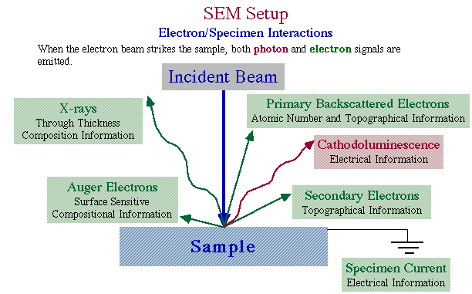

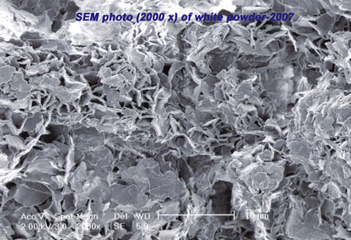

- (b)
Fig: (a) Interaction of electron beam with the sample in SEM
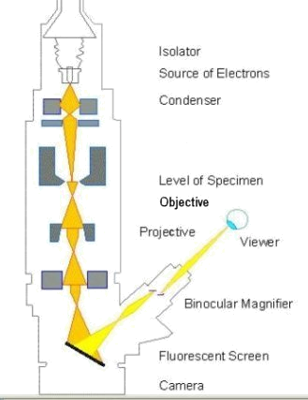
(b) SEM micrograph
(iii) Transmission electron microscopy (TEM)
TEM is another type of high resolution electron microscope, it gives the size of the particles more accurately than SEM, it is an unique tool in characterization of materials microstructure by diffraction and imaging techniques. In this instrument a beam of electrons is focused onto a specimen causing an enlarged version to appear on a fluorescent screen or CCD camera. The source of the electrons in TEM is thermionic discharge and the electrons produced are accelerated using electric field and controlled by electric, magnetic fields onto the sample. The advantage of this electron microscopic technique over SEM is that TEM shows
much very high resolution image. Fig: Interaction of electron
beam with the sample in TEM
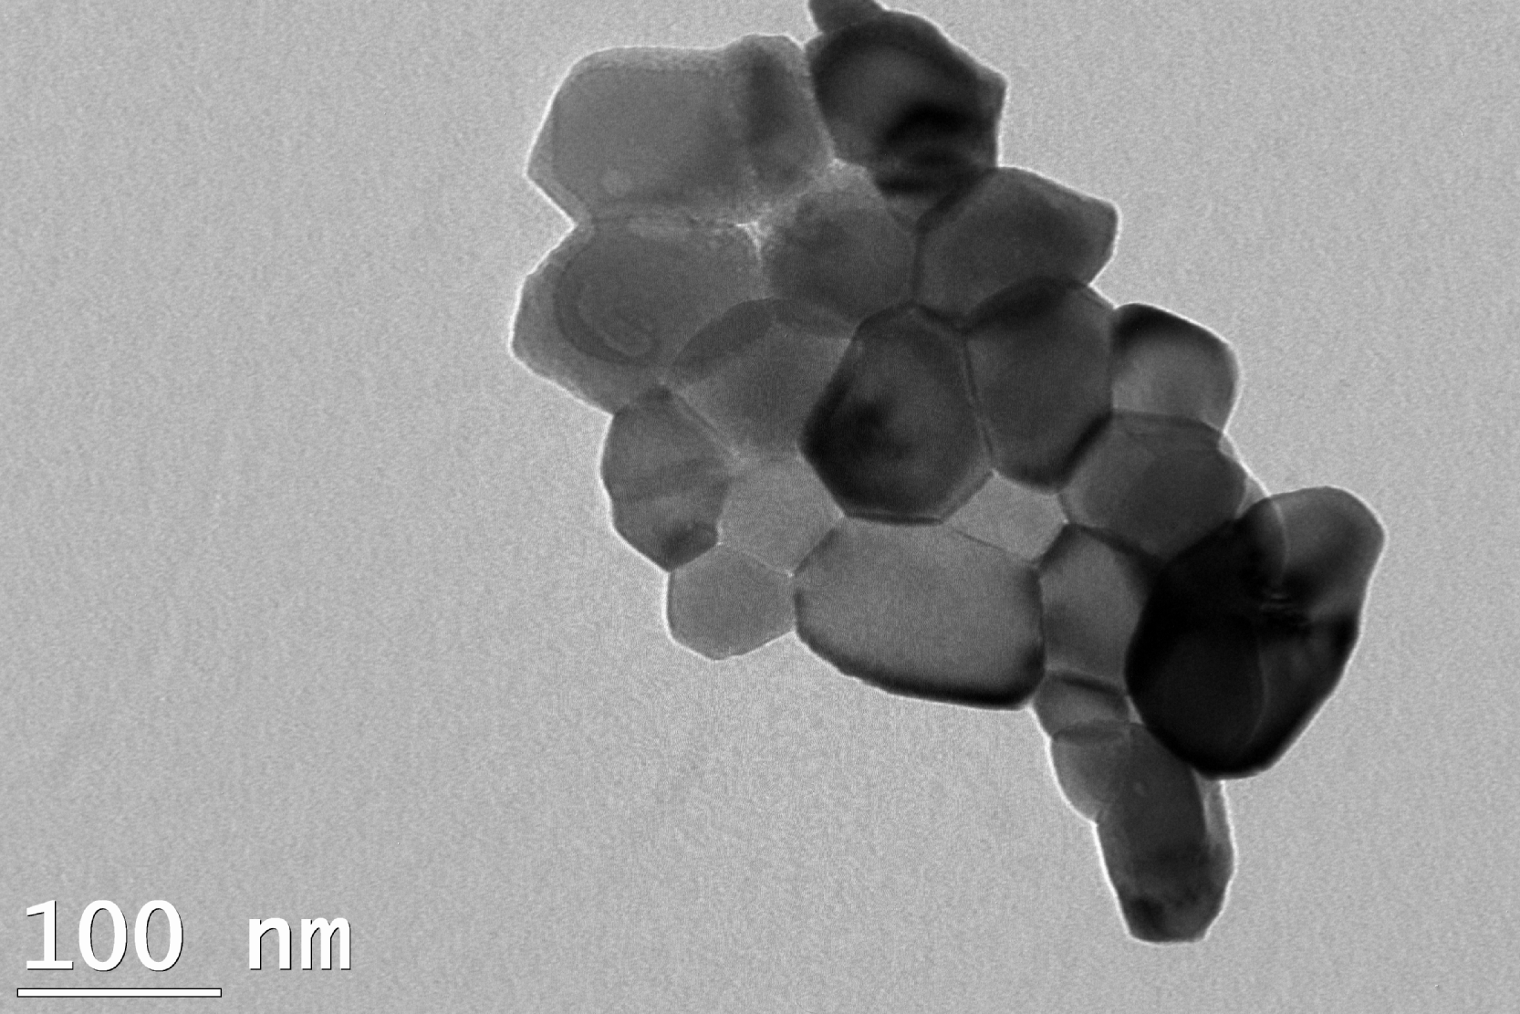
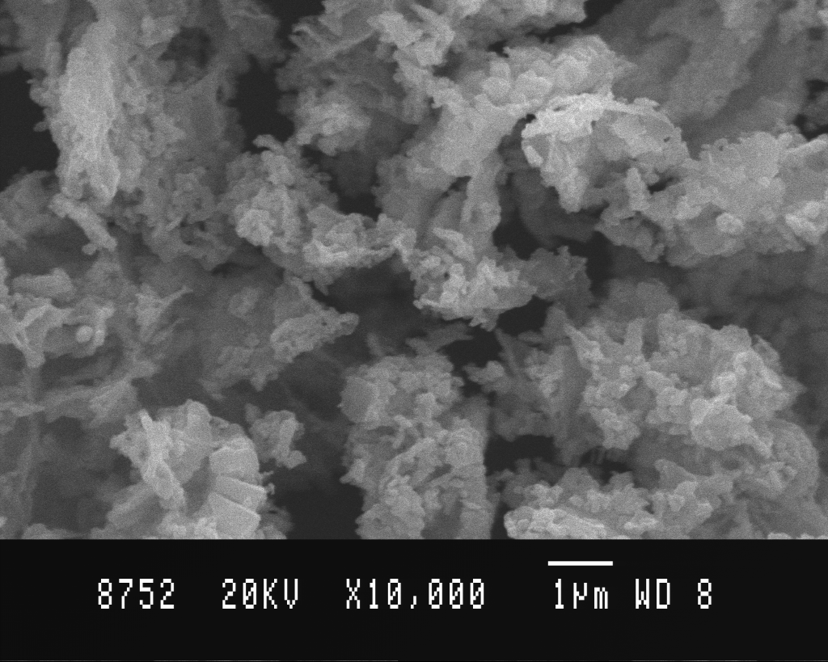

SEM TEM
Figs. Comparison of SEM and TEM micrographs of Zno nanoparticles

Q - What are the applications of nonmaterials
Nanomaterials possess unique optical, electronic and magnetic properties that make them unique and widely applicable in various fields.
- Health sector:
- Fe₂O₃ magnetic nanoparticles surrounded by a polymeric layer coated with affinity molecules, such as antibodies for capturing cells and other biological targets from blood or other fluids and tissue samples.
- Organically modified silica nanoparticles entrapped with anticancer drugs have been used to damage cancer cells.
- Cosmetics:
- Nano scale ZnO and TiO₂ particles are used in some sunscreen products. The nano scale versions of these particles retain the efficiency of their bulk analogues for protecting from UV radiations but they don’t scatter visible light making them transparent sunscreens.
- Sports and Toys
- Tennis balls using nano-clays are able to fill pores in batter way and trap the air pressure inside. This increases the life of balls.
- Tennis racquets are expected to have light weight, toughness and strength. It is shown that carbon nano tube composites would serve as a high strength, light weight material for racquets.
- Automobiles
- It is known that nano tube composites have mechanical strength better than even steel. So, use of these composites to built automobile parts would reduce weight of cars and hence power consumption.
Other Applications of Nanotechnology:

Examples | Application (field)
Diagnostics, Drug delivery, Tissue engineering, Cryonics | Medicine
Memory storage, Novel semiconductor devices, Electronic devices, Displays, Quantum computers | Information and communication
Aerospace, Catalysis, Catalysis, Construction Vehicle manufacturers | Heavy Industry
Foods, Household, Optics, Textiles, Cosmetics, Sports | Consumer goods
Water treatment: The removal of colour, heavy metal, fluoride, etc  - Nanomaterials have better photo catalytic activity than their bulk counterparts due to very high surface area. Nano photo catalysts like ZnO, TiO₂ and CuO are used to degrade organic dyes and other impurities from waste industrial waste water. | Environment

